**DATABASE USE IN DEMO**

National Traveling Salesman Problems

(<http://www.math.uwaterloo.ca/tsp/world/countries.html>)

**dj38.txt**

Djibouti Flag (CIA Factbook)

Djibouti - 38 Cities

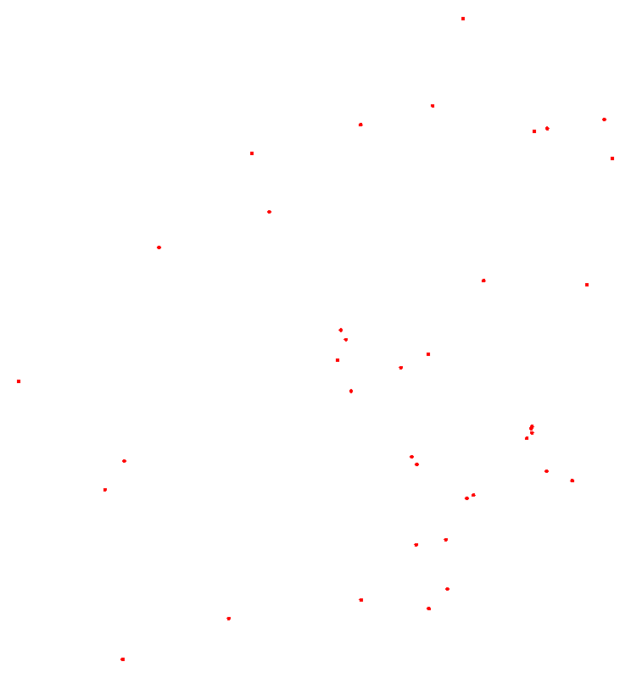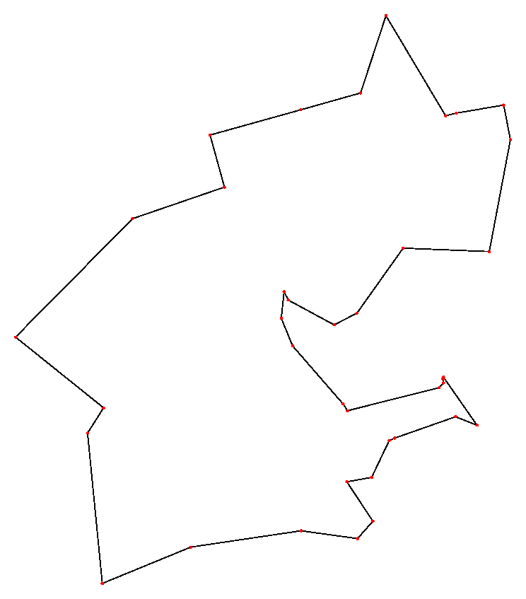

This is an optimal tour for the dj38 TSP instance. It has length 6656.

<http://www.math.uwaterloo.ca/tsp/world/djtour.html>

**qa194.txt**

Qatar Flag (CIA Factbook)

Qatar - 194 Cities

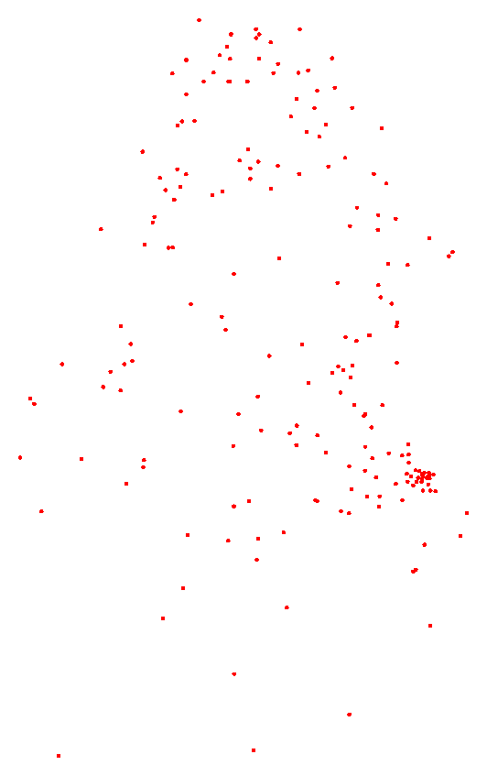

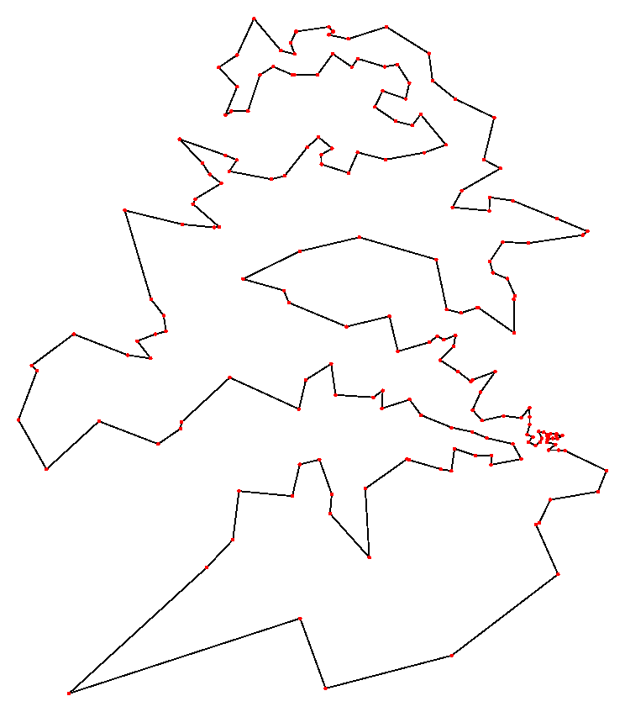

This is an optimal tour for the qa194 TSP instance. It has length 9352.

<http://www.math.uwaterloo.ca/tsp/world/qatour.html>

**wi29.txt**

Western Sahara Flag (African Studies Page)

Western Sahara - 29 Cities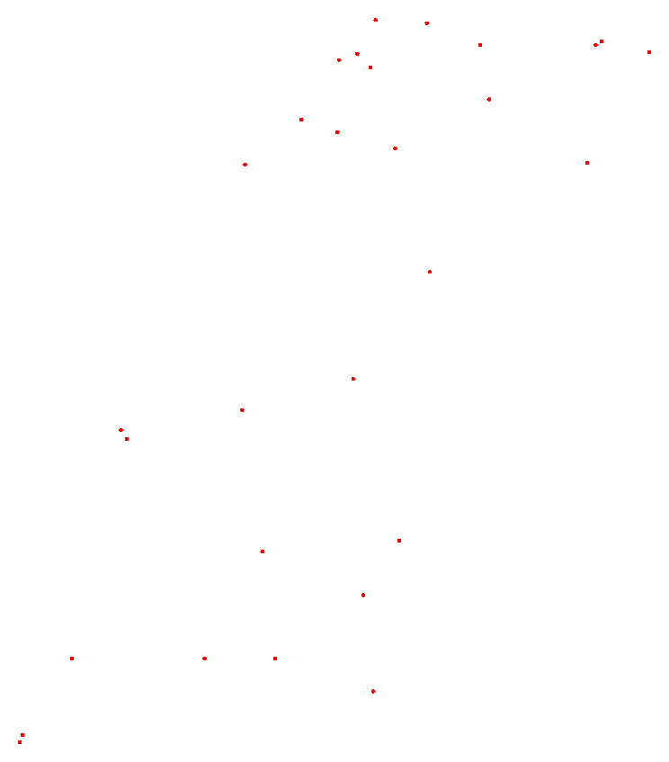

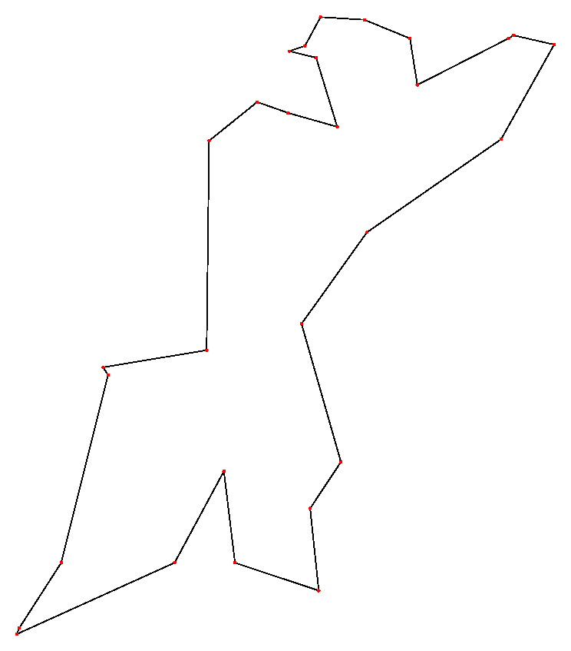

This is an optimal tour for the wi29 TSP instance. It has length 27603.

<http://www.math.uwaterloo.ca/tsp/world/witour.html>

**zi929.txt**

Zimbabwe Flag (CIA World Factbook)

Zimbabwe - 929 Cities

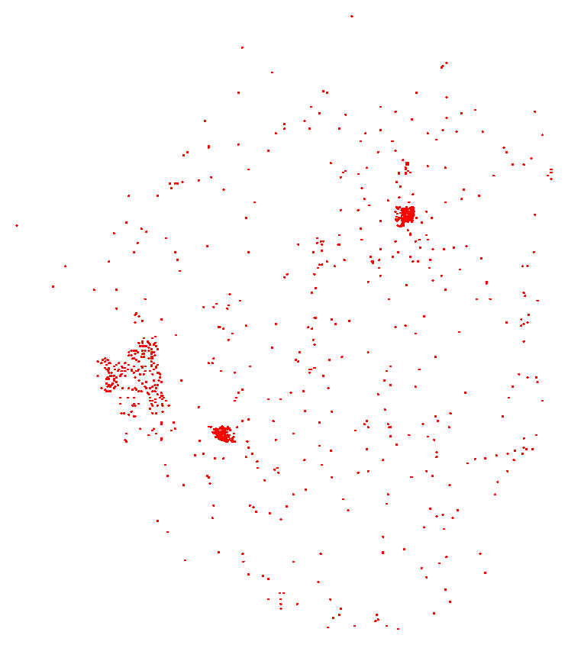

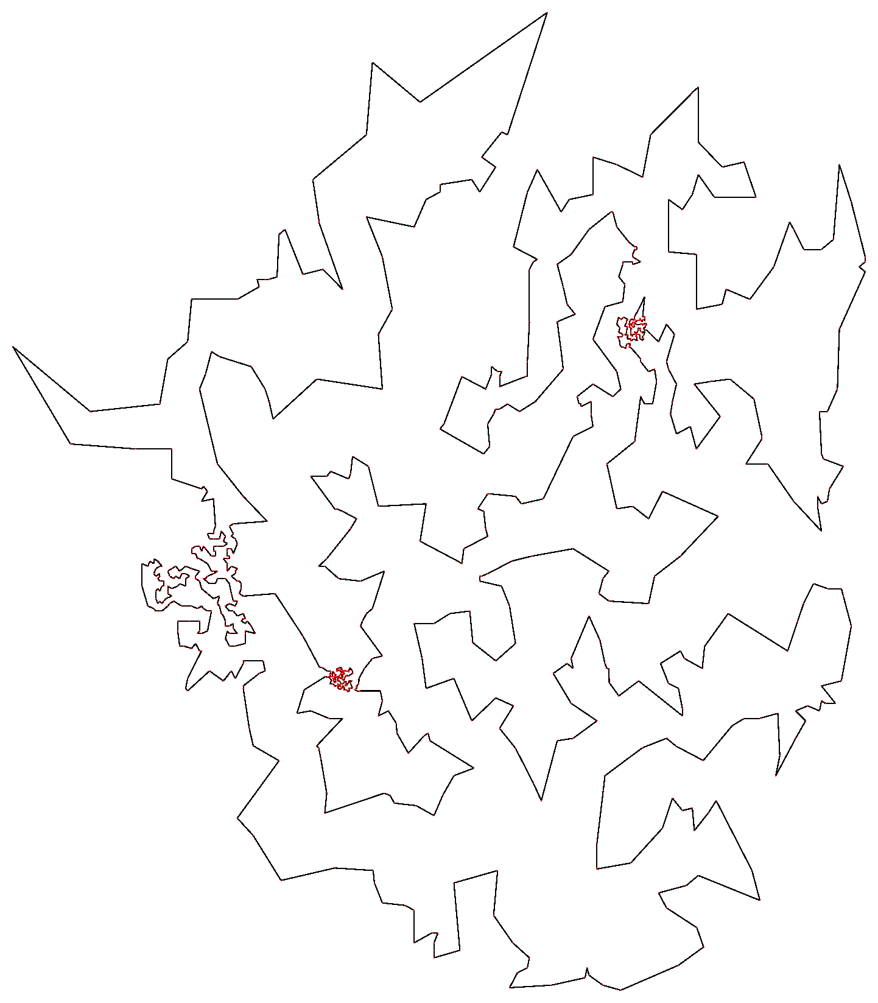

This is an optimal tour for the zi929 TSP instance. It has length 95345.

<http://www.math.uwaterloo.ca/tsp/world/zitour.html>